Bad examples of graphic design images



Reasons:

1.the size of the image is small so does not attract attention

2.its color is not attractive to create visual interest

3.the image is not enclosed in a shape to create an eye catching design



Reasons :

1.the words are not spacious to separate information

2.the image doesn’t have value

3.the surface of the information doesn’t appear to add depth to the nformation and create visual interest



Reasons:

1.there are no lines for stressed words or phrases

2.the color does not generate emotions nor create visual interest

3.the size of the image is small so does not attract attention nor create contrast

Examples of good graphic design images

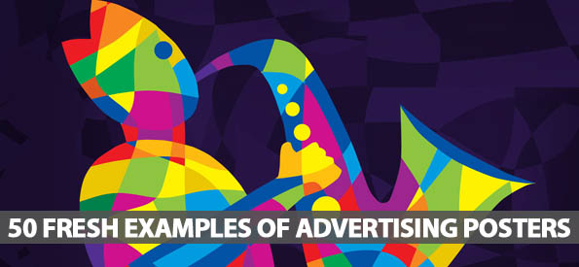

Reasons:

1.the image is enclosed in shape which helps create an eye catching design

2.the image is spacious helping give the eye rest and leading it directly to the information

3.the color of the image creates visual interest and helps generate emotions

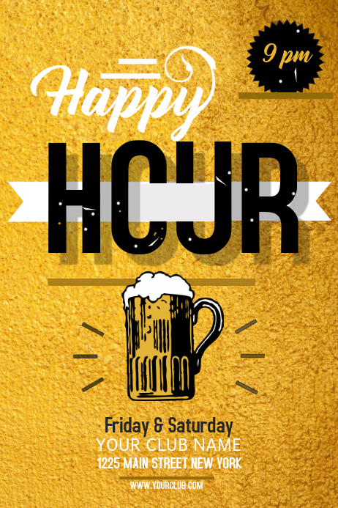

Reasons:

1.the texture of the image adds depth and visual interest

2.the size of the image is large enough to attract aattention and create contrast

3.a line has been used to stress the main phrase

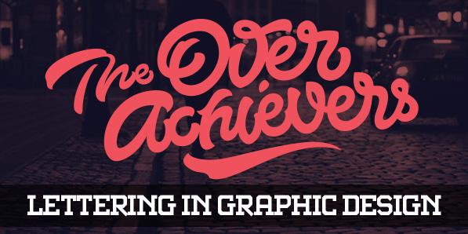

Reasons:

1.the image is enclosed in a shaped background hence creating an eye catching interest for vision

2.the color is bright to create visual interest

3.the words are spacious to define importance and lead the eye to the informaation